IoT Based Water Quality Testing & Water Supply Monitoring System

Zarif Ahmed Chowdhury
Computer Science and Engineering
BRAC University
Dhaka, Bangladesh
zarif.ahmed.chowdhury@g.bracu.ac.bd

Md Abu Fattah Hossain Bhuiyan
Computer Science and Engineering
BRAC University
Dhaka, Bangladesh
md.abu.fattah.hossain.bhuiyan.nahid@g.bracu.ac.bd

Md. Mahbub Rahman Shwon
Computer Science and Engineering
BRAC University
Dhaka, Bangladesh
md.mahbub.rahman.shwon@g.bracu.ac.bd

Omar Tanzim Zahid
Computer Science and Engineering
BRAC University
Dhaka, Bangladesh
omar.tanzim.zahid@g.bracu.ac.bd

Abstract— The paper suggests an Internet of Things IoT based implementation model to determine the water quality and amount of water usage in households in everyday life. In the proposed model we will use multiple sensors integrated together to collect data from the water body and analyze the data to determine the purity of the water. Furthermore, a flow sensor will also be used to measure the usage of water. The proposed is relatively a low-cost model which uses micro-controller and wireless communication (Wi-Fi) through our web-based and android platform. The results of our analysis are displayed to the users for ensuring a pure water quality and minimize the wastage of water.
Keywords— IoT, turbidity, Blynk, water quality, flow, water level, purity

Introduction
Water management is becoming an important issue in the present era. In most of the developing and under-develop countries ensuring pure drinking water for the citizens have been a major concern. Pure water quality is heavily reliant on the instrument used for the measurement. Parameters such as turbidity, acidity, temperature, light intensity, etc. are often being utilized for this purpose. In addition, a large quantity of water is being wasted every day without any accountability. In the paper we suggest a system which will measure the usage of water and determine the purity of water.
The principal focus of this paper is to propose a system that can ensure pure water quality in the households for the people. Here, the impurities that are mixed with the water will be identified and the concerned authority will be notified using android or web-based platform so that necessary steps can be implemented in removing those impurities from the water and providing pure water for everyone. The sensor value will be analyzed to give proper data which can help determine the purity.

Literature review
To measure water quality, the existing system analyzes important and harmful factors of water so that preventive actions can be taken. It uses pH sensor SEN0161 and turbidity sensor SEN0189 to collect the pH and turbidity level of the water. It uses ZigBee technology to acquire data from the remote areas. The sensors have the analog output; hence they are interfaced to analog input of the PIC microcontroller and the data are transferred through the ZigBee. Then the LCD along with a PC displays the real time data at the receiver section.

In this paper, multiple sensors like turbidity, temperature, etc. have been integrated together on nodeMCU to provide more accurate result and the real-time feedback will be provided which can be viewed using the android or web-based platform. Besides the water flow will also be measured which can allow taking steps in minimizing wastage of water. Since it uses an interactive GUI on both android and web platform, the concerned authority will find it much easier to read the information regarding the purity and usage of water.

Proposed System

In the proposed system multiple sensor have been used to take data from the water inside the tank and send it to the server via micro-controller and provide real-time feedback to the users through both android and web-based platforms. Whenever there is any problem or change in the water, a notification is sent to the concerned authority by an email for taking necessary precautions. Moreover, another sensor is integrated to measure the water usage of the household which can help minimize the wastage water.

Turbidity sensor:
A turbidity sensor indicates the degree at which the water loses its transparency by measuring the cloudiness of the water. Turbidity is considered as a good way to measure water quality. Turbidity blocks out the light needed by submerged aquatic vegetation.

DHT11 Sensor:
A DHT11 Sensor features a calibrated digital signal output with the temperature and humidity sensor capability. Through this technology high accuracy and great long-term stability can be obtained. This sensor includes a resistive element and a sensor for wet NTC temperature measuring devices. It measures the humidity and temperature inside the tank.

Ultrasonic Sensor:

Ultrasonic sensors measure distance by using ultrasonic waves. This sensor is used to measure the water level in the tank.

Flow sensor:

Flow sensors are devices that are used to measure the flow rate of a moving liquid. This sensor basically consists of a plastic valve body, a rotor and a Hall Effect sensor. The pinwheel rotor rotates when water / liquid flows through the valve and its speed will be directly proportional to the flow rate. The Hall Effect sensor will provide an electrical pulse with every revolution of the pinwheel rotor.

NodeMCU:

NodeMCU is an open source IoT platform. This includes firmware that runs runs on the ESP8266 Wi-Fi SoC hardware which is based on the ESP-12 module. It does the interfacing between the sensors and the processor.
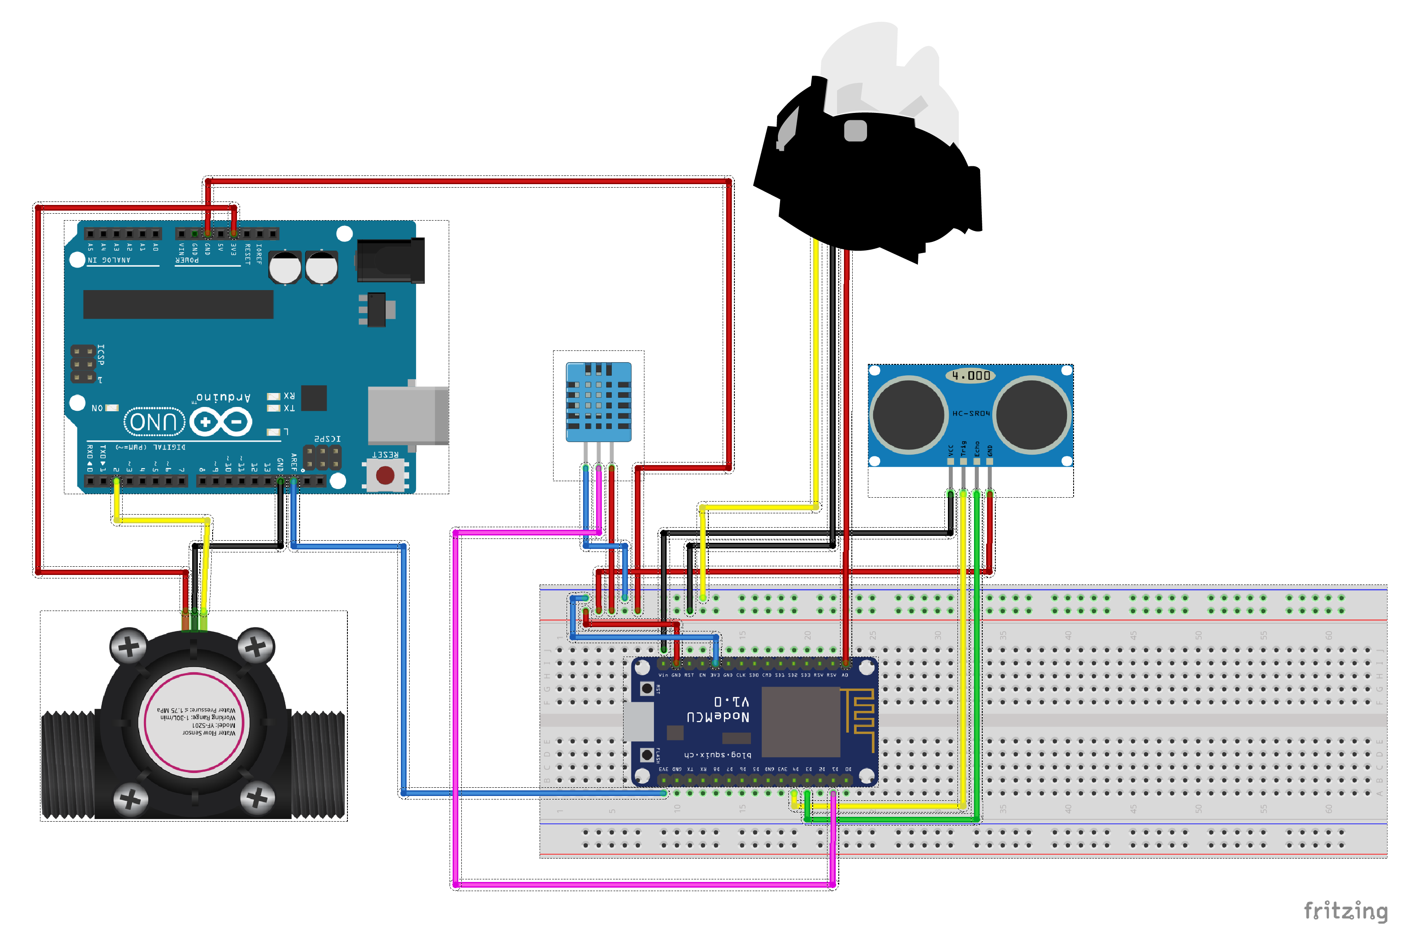

Fig1.1: Fritzing Model of System

Software Implementation

This paper has proposed a system which provides both web-based and android-based software. The two softwares that have been used are Blynk and Thingspeak. The concerned authority can view the live information of the water tank in both of this software.

Blynk: The Blynk application shows the turbidity, humidity, temperature, flow rate and water level in the tank in an attractive GUI. It is an android based platform where users can create their own apps and use them to display their system.

ThingSpeak: Thingspeak is the open IoT based platform with MATLAB analytics. In this web-based application, the information is represented in well-designed graphs which shows real-time feedback to the users.

Flow chart

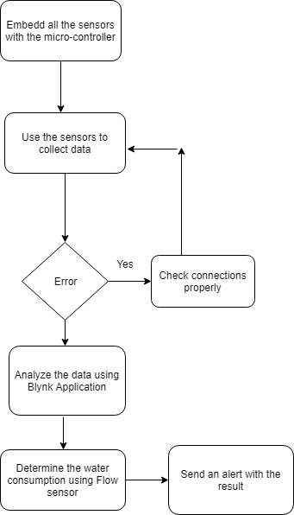

Result And Analysis
The data collected from sensor values will be displayed to the users using the aforementioned platforms. The results are presented using different gauges and graphs by which the users can check the current situation of their water tank.
The sensor values are transmitted to the thingspeak and blynk server wirelessly by the NodeMCU. The data can be monitored frequently and displayed on every action. The user will also receive email notifications if there is any regularity in the water. Whenever the turbidity reaches below 4 the user is notified with an email to take an action. Similarly, there are also notified if the temperature is above the regular or if the water level inside the tank is below 25%.
The water flow from the tank is also displayed by which the water usage of the households can be measured.

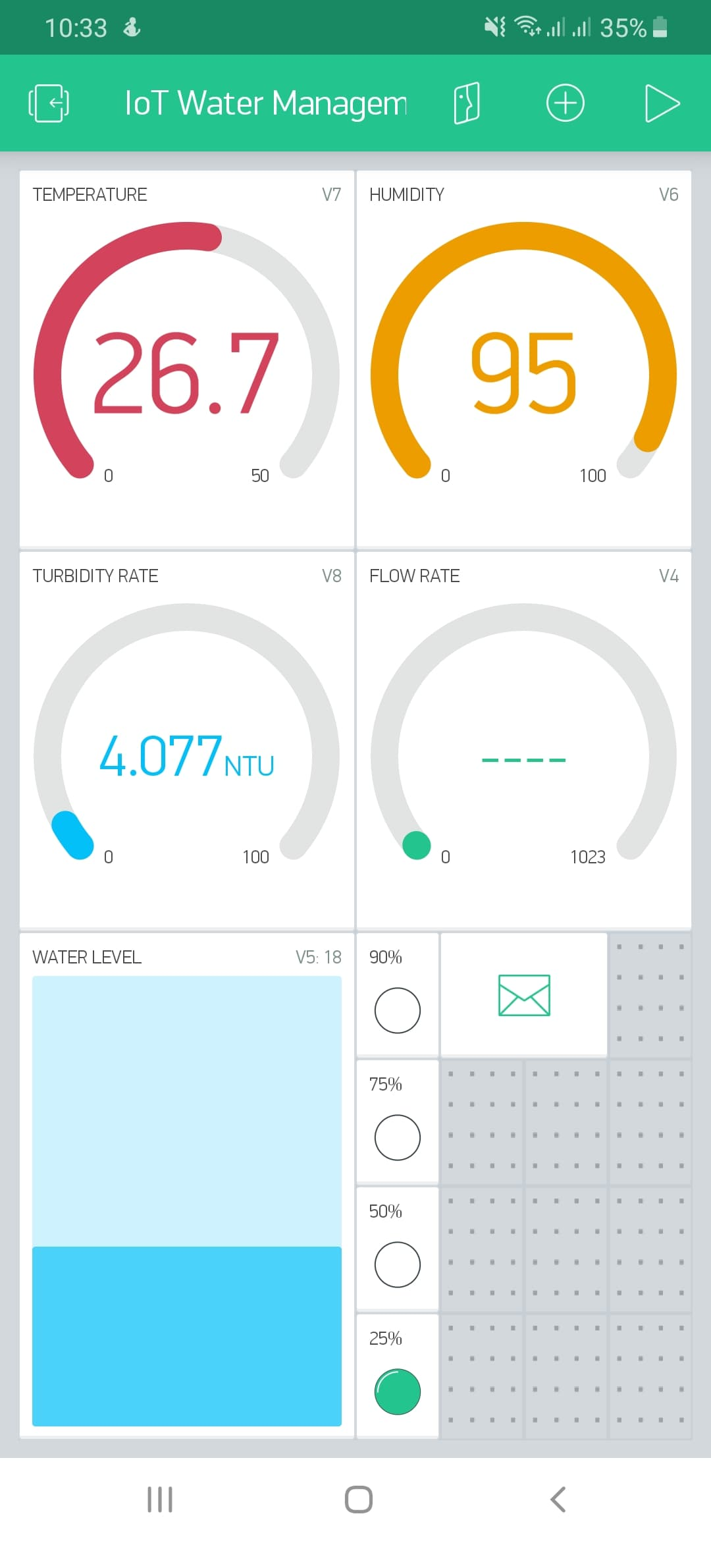
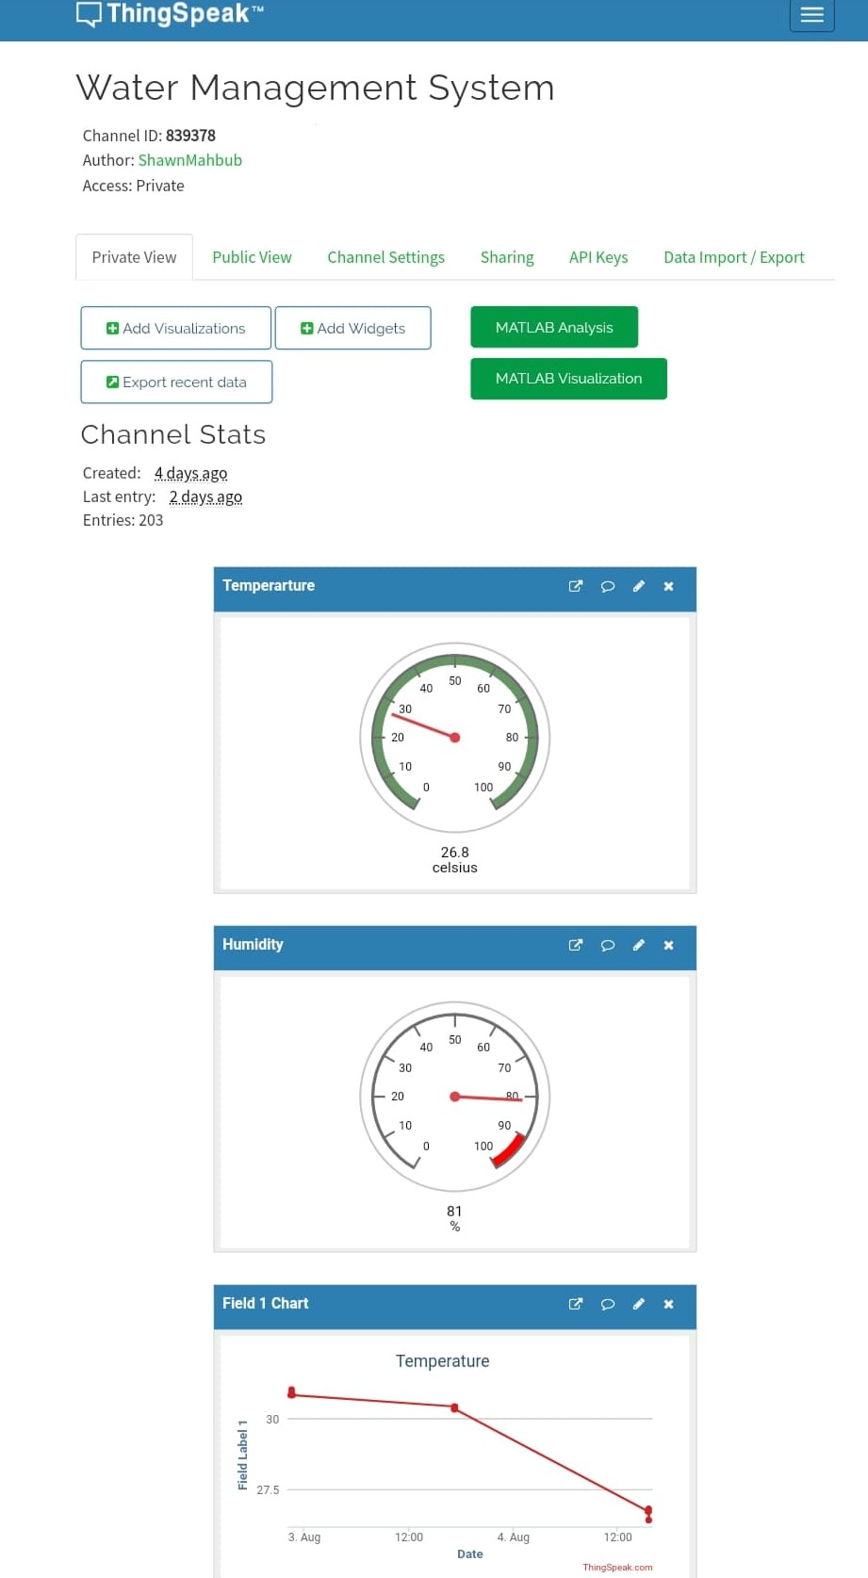
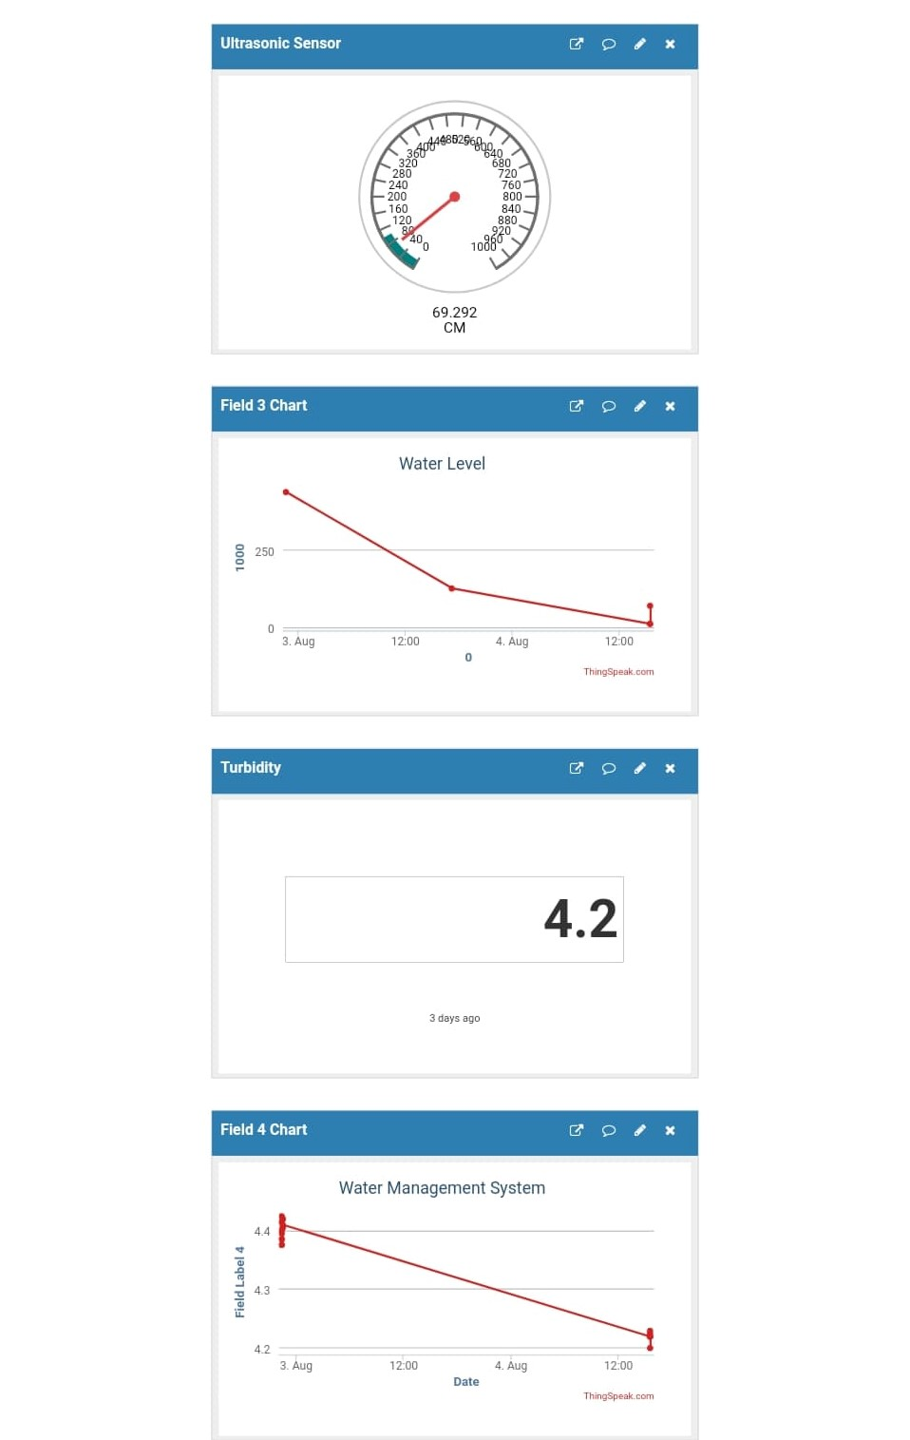

Conclusion
The system works smartly to interface all the collected data to control quality of our daily water usage, and ultimately aims efficient usage of water and reducing wastage. The time intervals for collection of data can be altered if required to, and the sensors verify several parameters and ensure good quality of water throughout. Data can be accessed from anywhere at any time, and we would be notified instantly if problems occur, so it saves our time and saves us a lot of trouble as well. Hence, faults can be quickly fixed and that is desirable for everyone. The system is convenient to install in households and it is in harmony with the ecological environment as well. It will be useful for not only individual households, but also for the society as a whole.

References

- V. Raut, S. Shelke, "Wireless acquisition system for water quality monitoring", 2016 Conference on Advances in signal Processing (CASP), pp. 371-374, 2016.
- K.H. Kamaluddin, W. Ismail, “Water quality monitoring with internet of things (IoT)”, 2017 IEEE Conference on Systems, Process and Control (ICSPC), 2017
[3] Li S, Xu L, Wang X & Wang J, “Integration of Hybrid Wireless
Networks in Cloud Services Oriented Enterprise Information
Systems”, Enterp. Inf. Syst., Vol.6, No.2, (2012), pp.165–187.

[4] Heinzelman WR, Kulik J & Balakrishnan H, “Adaptive protocols

